Summary and Reflections Report
Cindi Cunnius
Southern New Hampshire University
CS-320 Software Test Automations
Jonathan Norman
April 15, 2026

Summary and Reflections Report
Contact Service
For Project One, I was responsible for developing and testing a mobile application by focusing on implementing core features and verifying that they met specific software requirements. My main task was to create classes that followed strict constraints, limiting field lengths, preventing null values, and ensuring each object had a unique identifier. These requirements along with the rubric and module resources guided me on how I structured the code and how each method behaved.
I was required to develop JUnit tests to validate the functionality of each feature. I created test cases that covered both valid and invalid scenarios, including edge cases like exceeding character limits or passing null values. The goal was to ensure that the system handled all inputs correctly and threw appropriate exceptions when requirements were violated.
I also needed to ensure that my tests aligned directly with the requirements, meaning every rule defined in the project had at least one corresponding test. This helped confirm that the application behaved as expected and maintained data integrity.
Overall, the project required me to think both as a developer and as a tester. I had to carefully implement features according to specifications while also critically evaluating my own code through thorough testing to ensure reliability and correctness. I encountered a few setbacks, mainly spelling, organizing my code and not knowing what line to put the test on. After fixing those flaws, my code ran smoothly.
Task Service Project
For the task service project, I was tasked with developing the task service portion of a mobile application based on specific customer requirements. My responsibility was to design and implement both the Task class and the TaskService class and then verify their functionality using JUnit tests.
First, I needed to create the Task object, ensuring it followed strict constraints. Each task had to include a unique task ID that could not exceed 10 characters, could not be null, and could not be changed once created. In addition, I had to implement a name field of a maximum of 20 characters and a description field of a maximum of 50 characters, both of which were required and could not be null. I needed to enforce these rules directly in the class by validating inputs and throwing exceptions when constraints were violated.
Next, I developed the TaskService class, which manages task objects using an in-memory data structure rather than a database. This service needs to support adding new tasks with unique IDs, deleting tasks by their ID, and updating existing task fields. The only fields I was allowed to update were the task’s name and description, so I had to ensure that updates followed the same validation rules as when the task was created.
After implementing the classes, I created JUnit test files to verify that all functionality worked correctly and met the requirements of the rubric. These tests checked both valid operations and invalid scenarios, such as attempting to add duplicate task IDs, passing null values, or exceeding character limits. The goal was to confirm that the system behaved as expected and properly handled errors.
Overall, this project required me to apply object-oriented programming principles, enforce strict validation rules, and thoroughly test my code to ensure reliability and correctness. I encountered a few errors that were shown to me during my test, codes that I added in lines that were correct but weren’t prompting anything to complete. I often had to reorganize my lines of code.
Appointment Service Project
For this project, I was tasked to develop the appointment service portion of a mobile application based on the customer’s requirements. My task was to design and implement both the Appointment class and the AppointmentService class and then to verify their functionality using JUnit tests.
First, I created the Appointment object, making sure it followed all required rubric requirements and constraints. Each appointment needed a unique appointment ID that could not exceed 10 characters, could not be null, and could not be changed after creation. I also implemented an appointment date field using java.util.Date, ensuring that the date was not null and could not be set in the past by checking it against the current date. In addition, I included a description field that was required, could not be null, and could not exceed 50 characters. I enforced all of these rules through validation logic within the class.
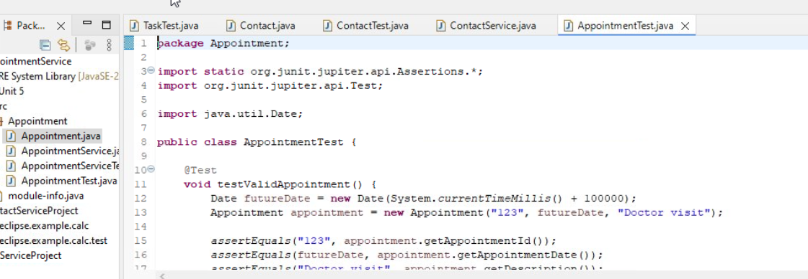
I used import java.util.Date; in the Appointment class to work with date objects, allowing me to store and validate appointment dates. This was necessary to ensure that each appointment had a valid date value and to support logic that checked whether the appointment date was in the past using before(new Date()), which helped enforce the requirement that appointments cannot be scheduled for past dates.
After that, I developed the AppointmentService class, which manages appointment objects using an in-memory data structure instead of a database. This service needed to support adding new appointments with unique IDs and deleting appointments based on their ID. I ensured that duplicate IDs were not allowed and that deletion operations handled both valid and invalid cases appropriately.
After implementing the classes, I created JUnit test files to verify that all functionality worked as expected. I wrote tests for both valid and invalid scenarios, such as attempting to create appointments with past dates, null values, overly long fields, or duplicate IDs. These tests helped confirm that the application correctly enforced all requirements and handled errors properly.
Overall, this project required me to apply validation logic, manage in-memory data structures, and thoroughly test my code to ensure it met the customer’s requirements and functioned reliably.
Software Requirement Reflection
When I used Eclipse to run my JUnit tests, I relied on the Run Configurations and JUnit testing tools to verify whether my code was working correctly and how much of it was actually being tested. To run my tests, I created a JUnit Test configuration in Eclipse. This allowed me to select my test classes like TaskTest or AppointmentServiceTest and execute them all at once. After running the tests, Eclipse displayed the results using a color-coded system along with coverage percentages when I used the coverage tool.
When the tests ran, I looked at the color bar in the JUnit view: if I saw a green bar, it meant all my tests passed successfully, and my code behaved as expected for the cases I tested. If I saw a red bar, it meant at least one test failed. In those cases, I reviewed the failure message and stack trace to identify what went wrong, often times it was my mistake with spelling, or invalid logic or missing validation.
In addition to pass/fail results, I used Run with Coverage to check how much of my code was actually tested. Eclipse showed this as a percentage value, which represented how much of my code was executed during testing. I aimed for a higher percentage like 90%–100% which meant that most of my code, including different branches and conditions, was being tested. In the beginning of my codes a lower percentage indicated that some parts of my code were not being executed by my tests, meaning I needed to add more test cases this helped guide me in a direction to aim for the 90%.
Overall, I knew my tests were effective when: I consistently received a green bar and my coverage percentage was high, showing that I tested both normal and edge cases. This process helped me confirm that my code was not only correct but also thoroughly tested.
Effectiveness of JUnit Tests
When the tests ran, I looked at the color bar in the JUnit view to evaluate their effectiveness. If I saw a green bar, it meant all my tests passed successfully, and my code behaved as expected for the cases I tested. I rarely saw this measurement when I first started my test run. I often got low results in my first few runs 32.5%-45%. This was because I wasn’t fully finished with my codes and I left out measures and nulls. I used the failure messages and stack traces to identify issues such as spelling errors, invalid logic, or missing validation.
In addition to pass/fail results, I used this feature to measure how much of my code was being tested. Eclipse displayed this as a percentage value, which showed how much of my code was executed during testing. I aimed for a high coverage percentage, around 90%–100%, because this indicated that most of my code, including different branches and edge cases, was being tested.
In the beginning when my coverage was lower, it showed that some parts of my code were not being executed, which guided me to add more test cases. Overall, I knew my tests were effective when I consistently received a green bar and achieved high coverage, confirming that my code was both correct and thoroughly tested. This technique helped my code throughout this project and helped me achieve higher percentages I aimed to have all of my projects to be above 80%. I succeeded in this with the assistance of Junit testing.
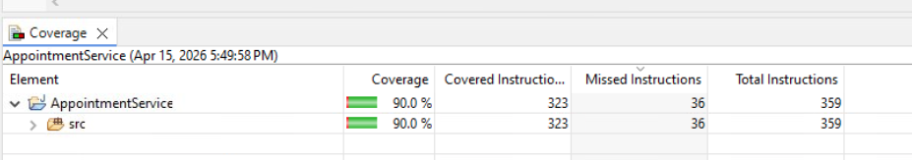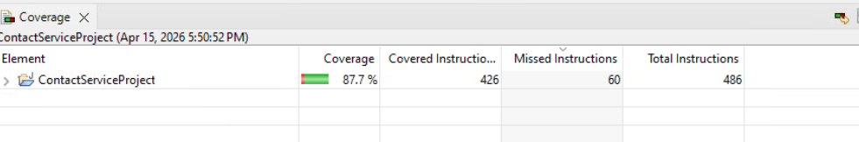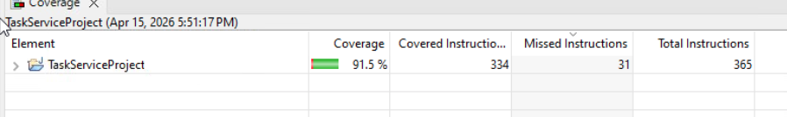
Bias and Discipline
Throughout this project, I had to actively limit bias when testing my own code. Because I was both the developer and the tester, it was easy to assume that my code worked correctly if it compiled or passed initial test cases. To avoid this, I intentionally designed test cases that focused on invalid inputs and edge cases, such as null values, exceeding character limits, and duplicate IDs, rather than only testing expected successful outcomes.
This helped ensure that I was evaluating the code objectively and not overlooking errors due to familiarity with my own implementation. I also learned the importance of maintaining discipline in my approach to development and testing to avoid technical debt. When I rushed or skipped writing thorough test cases early on, I later had to go back and fix issues that could have been caught sooner, which increased the time and complexity of debugging. By consistently writing tests alongside development and fully validating each requirement, I was able to reduce rework, maintain code quality, and prevent issues from accumulating into larger problems later in the project.
I created a schedule for coding during this project, rough draft following the requirements. Then I started with the requirements of the package. Following that I created basic lines of code. After those codes, I added detail. I ran tests after every other line to ensure I was doing things correctly. I also saved often too, after each test. This disciplined approach helped me reduce errors early in development and prevented issues from building up later in the code. By testing frequently, I was able to quickly identify and fix problems as they occurred instead of trying to locate multiple issues at the end. It also helped me avoid technical debt by ensuring that each part of the program was validated before moving on to the next section, which kept my code organized, consistent, and easier to debug throughout the project.
Testing Techniques
Throughout this project, I used several software testing techniques to ensure the application met all requirements and functioned correctly. One of the main techniques I used was unit testing, where I tested individual methods and classes in isolation to confirm that each part of the system worked as intended. This helped me verify that each function in the Task and Appointment services behaved correctly before combining them with other components.
I also used boundary value analysis by testing input limits such as maximum and minimum allowed values for fields like task ID length, name length, description length, and appointment date restrictions. This was important for confirming that the system correctly enforced constraints at the edges of valid input ranges.
Another technique I applied was equivalence partitioning, where I grouped inputs into valid and invalid categories. For example, valid inputs included correctly formatted IDs and non-null values, while invalid inputs included null values, duplicate IDs, and overly long strings. This helped reduce redundant test cases while still ensuring full coverage of expected behaviors.
In addition, I used negative testing by intentionally providing invalid inputs to ensure the system handled errors properly. This included testing null values, past dates in the Appointment class, and duplicate task IDs in the TaskService class. These tests confirmed that the application correctly rejected invalid data and maintained data integrity.
Overall, using these testing techniques helped me create more structured and effective JUnit tests, ensuring that both expected and unexpected inputs were properly evaluated.

